

**Used cars price predicting model**

Project Report

**Machine Learning**

**(CSE4036)**

M.Tech CSE with Specialization in Business Analytics

**School of Computer Science and Engineering (SCOPE)**

**VIT Chennai**

**FALL Inter Sem 2022-2023**

**Slot: D1**

**Submitted by**

**Raguram M – 21MIA1100**

**Ram Sundar S – 21MIA1032**

**Maha dev M – 21MIA1011**



**CERTIFICATE**

This is to certify that the project work entitled “USED CAR PRICE PREDICTION” that is being submitted by the above mentioned team members is а record of bonаfidе work done under my supervision. The content of this project work, in full or in parts, have neither been taken from any other source nor have been submitted for any other course.

Place: Chennai Signature of faculty

Date: 18/07/2023 Dr.A.Vinothini

**АCKNOWLЕDGЕMЕNT**

We would like to express our special thanks and gratitude to our Course faculty Dr**.A.Vinothini**, Assistant Professor of School of Computer Science and Engineering who gave us the golden opportunity to do this wonderful project titled “ “, and also for providing us with proper guidance and suggestions to develop this project. This helped us in doing а lot of research and we came to know about so many new things.

We are extremely grateful to **Dr. Ganesan R** **, Dean** of School of Computer Science and Engineering, VIT Chennai, for extending the facilities of the School towards our project and for his unstinting support.

We express our thanks to our Head of the Department Dr. **Sivabalakrishnan M** for his support throughout the course of this project.

We also take this opportunity to thank all the faculty of the School for their support and their wisdom imparted to us throughout the course.

We thank our parents, family, and friends for bearing with us throughout the course of our project and for the opportunity they provided us in undergoing this course in such a prestigious institution.

**CONTENTS**

|  |  |
| --- | --- |
| **Title** | **Page No** |
| 1. Abstract | 5 |
| 1. Introduction | 6 |
| 1. Literature Survey | 8 |
| 1. Tools used | 9 |
| 1. Dataset | 11 |
| 1. Working modules and flow chart & system design of proposed work    1. Importing libraries    2. Data collection    3. Data processing    4. Data cleaning    5. Feature engineering | 13 |
| 1. Innovation | 28 |
| 1. Results and discussion | 29 |
| 1. Conclusion and Future Work | 31 |
| 1. Contributions of each team member | 32 |
| 1. References | 32 |

**ABSTRACT**

Predicting the prices of used cars is a challenging task due to the various factors that influence their value. This project aims to develop a machine learning model that can accurately predict the prices of used cars based on their features. The prediction of used car prices through machine learning models offers several practical benefits, making it a valuable and useful tool in various scenarios.

Predicting used car prices allows buyers and sellers to make more informed decisions. Buyers can estimate the fair market value of a car they are interested in, helping them negotiate prices and avoid overpaying. Sellers can assess the appropriate listing price for their vehicle, maximizing their chances of a successful sale.

Used car price prediction models contribute to increasing transparency in the market. They provide a standardized and objective approach to determining a car's value, reducing information asymmetry between buyers and sellers. This can foster trust and efficiency in transactions.

Online marketplaces or car dealerships can utilize price prediction models to evaluate and validate the listed prices of used cars. This helps ensure fair and competitive pricing, enhancing customer satisfaction and loyalty. Predicting used car prices assists lenders and insurers in assessing the risk associated with financing or insuring a particular vehicle. Accurate price estimation enables better decision-making regarding loan terms, interest rates, or insurance premiums.

Overall, used car price prediction using machine learning models facilitates fair pricing, informed decision-making, and transparency in the used car market. It benefits buyers, sellers, marketplaces, lenders, insurers, and other stakeholders by providing reliable estimates of a used car's value, streamlining transactions, and promoting market efficiency.

**INTRODUCTION**

The used car market is a thriving industry with a significant demand for accurate pricing information. Whether you are a buyer trying to negotiate a fair deal or a seller looking to determine the optimal listing price, having an accurate prediction of used car prices is essential. This project aims to address this need by developing a machine learning model that can effectively predict the prices of used cars based on their features.

Calculating a used car's worth accurately requires careful consideration of several different aspects, including the vehicle's brand, model, year of production, mileage, fuel type, gearbox type, and more. Combinations of these factors can affect used automobile value, making it difficult to manually evaluate their effects and determine an appropriate appraisal.

When buying a used car, several questions arise about its price. Some of the common questions :

**What is the fair market value of the used car?** : Buyers often want to determine the reasonable and fair price for a specific used car based on its make, model, year, mileage, and other relevant factors.

**Is the listed price of the used car reasonable?** : Buyers may question whether the listed price of a used car aligns with its condition, age, mileage, and features compared to similar vehicles in the market.

**What factors affect the price of the used car?** : Buyers are interested in understanding which specific features or characteristics of the used car influence its price. This may include factors such as the car's make, model, year, mileage, condition, previous owners, and additional features.

**How does the price of the used car compare to its market value?** : Buyers want to assess whether the price being asked for the used car aligns with its estimated market value. This helps them gauge whether the seller's asking price is too high or represents a good deal.

**Are there any hidden costs associated with the purchase**? : Buyers need to inquire about any additional costs or fees related to the purchase, such as taxes, registration fees, insurance, or potential repair expenses.

A potentially effective approach to this problem is machine learning. We may harness the power of computers to understand patterns and links between the automobile attributes and their related pricing by training a model on a large dataset of used cars. The trained programme may then use this information to create precise predictions for automobiles it hasn't yet seen. The study uses a methodical process to forecast used automobile values. To make sure the dataset is appropriate for training the machine learning model, it starts with data pretreatment and feature engineering. In order to correct for biases, missing data is handled, categorical variables are encoded, and numerical characteristics are scaled or normalised. Once the dataset is prepared, it is divided into training and testing sets. Various machine learning algorithms, such as linear regression, decision trees, or ensemble methods, are explored to identify the most effective model for predicting used car prices.

Overall, this project aims to leverage the power of machine learning to develop a reliable used car price prediction model. By providing accurate and transparent price estimates, it empowers buyers, sellers, and marketplaces to make informed decisions, negotiate fair deals, and enhance overall market efficiency.

**LITERATURE SURVEY**

* "A Review on Car Price Prediction Using Machine Learning Techniques“ by Akeem Olowe et al. (2021)
* "Predicting Used Car Prices: A Comprehensive Review of Machine Learning Approaches" by Kavya Kulkarni and Remya Krishnan (2020)
* "A Review on Resale Value Prediction of Used Cars using Machine Learning Techniques" by Ankita Mishra and Anil Kumar Singh (2019)
* "Used Car Price Prediction using Data Mining Techniques: A Survey" by Brahim Brahimi and Abdelouahab Moussaoui (2021)
* "Used Car Price Prediction: A Comprehensive Study with Feature Importance Analysis" by Nidhi Bhatla and Sukhjeet Singh Sehra (2020)
* "Machine Learning-Based Used Car Price Estimation: A Systematic Review of Empirical Studies" by R. Prakash and S. Arjunan (2018)
* "Predicting Resale Value of Used Cars: A Review of Recent Advances in Machine Learning“ by Yuze Li et al. (2019)
* "A Study of Machine Learning Approaches for Used Car Price Prediction“ by S. Ramya and V. M. Deepa (2019)
* "Used Car Price Prediction Using Machine Learning Techniques: A Literature Review“ by Mohammed Benbrahim et al. (2020)
* "A Comprehensive Review on Used Car Price Prediction using Machine Learning Techniques" by Rajeev Kumar and M. Kannan (2020)

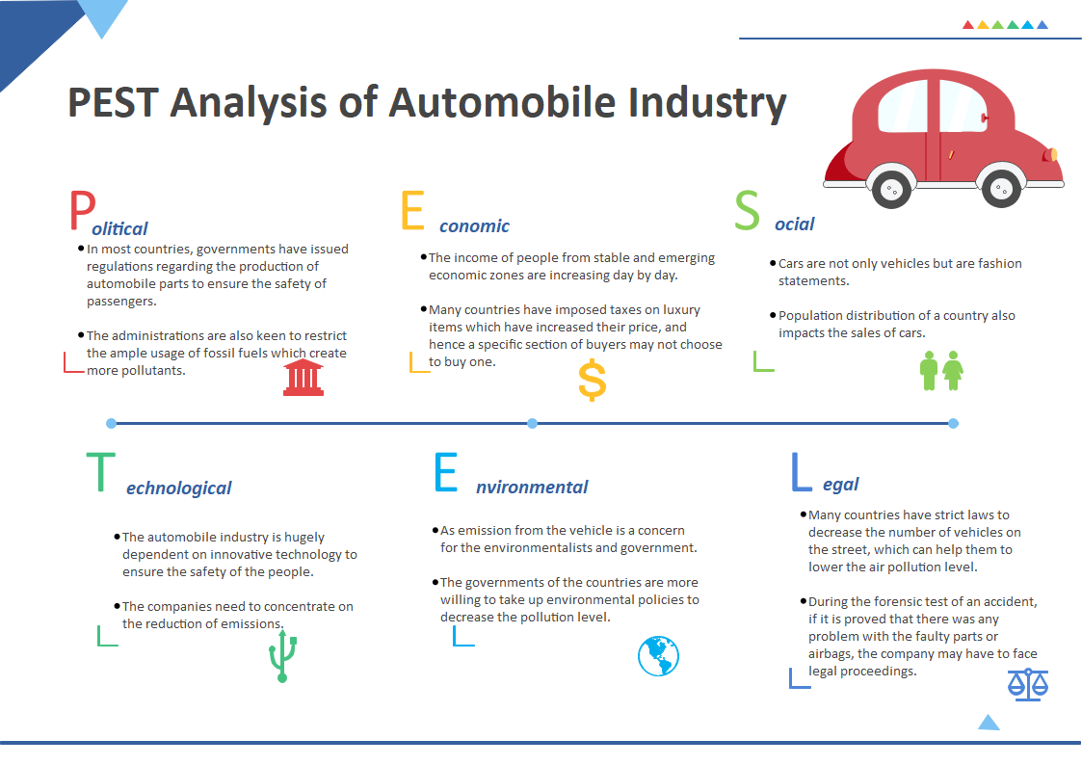

Figure 1 PESTEL Analysis of automobile Industry

**TOOLS USED**

The project of predicting used car prices may involve the use of various tools and technologies. Here are some common tools that can be used throughout different stages of the project:

1. **Python:** Python is a popular programming language for data analysis and machine learning. It offers a wide range of libraries and frameworks that facilitate data preprocessing, feature engineering, model training, and evaluation. Some commonly used Python libraries for this project include NumPy, Pandas, Scikit-learn, and Matplotlib.
2. **Jupyter Notebook or JupyterLab:** Jupyter Notebook or JupyterLab provides an interactive coding environment that allows for exploratory data analysis, running code cells, and generating visualizations. It enables step-by-step execution and documentation of the project, making it easier to share and present the results.
3. **Pandas:** Pandas is a powerful Python library for data manipulation and analysis. It provides data structures and functions to handle data in tabular form, making it convenient for tasks such as data cleaning, preprocessing, and feature selection.
4. **Scikit-learn:** Scikit-learn is a widely used machine learning library in Python. It offers a comprehensive set of tools for various machine learning tasks, including regression and classification. Scikit-learn provides efficient implementations of popular algorithms, as well as evaluation metrics and utilities for model selection and preprocessing.
5. **Matplotlib and Seaborn:** Matplotlib and Seaborn are Python libraries for data visualization. They enable the creation of various types of plots, charts, and graphs to visually analyze and present the data, evaluate model performance, and illustrate insights.
6. **NumPy:** NumPy is a fundamental library for scientific computing in Python. It provides efficient numerical operations and multi-dimensional array processing capabilities. NumPy is often used for data preprocessing, feature scaling, and mathematical computations in machine learning workflows.
7. **Featuretools:** Featuretools is a Python library for automated feature engineering. It allows for the creation of new features from existing datasets, capturing complex relationships and patterns. Featuretools can be beneficial in enriching the dataset with additional informative features for improved model performance.
8. **Model Evaluation Metrics:** Various metrics are used to evaluate the performance of machine learning models. These include mean squared error (MSE), mean absolute error (MAE), R-squared score, and accuracy metrics specific to regression tasks. These metrics are implemented in libraries like Scikit-learn and can be used to assess the model's accuracy and effectiveness.

It is important to note that the choice of tools may vary depending on personal preferences, project requirements, and familiarity with specific libraries. The mentioned tools provide a solid foundation for conducting the project of predicting used car prices, but other alternatives may also be suitable depending on individual preferences and project needs.

**DATASET**

The **test-data.csv** ***first dataset*** we used for this project was acquired from Kaggle. The Kaggle open dataset was downloaded as a CSV file, cleaned and validated with Wikipedia data for reliability. The dataset contains information on from 1998 up to 2019 cars.

1. **Dataset Description:** The dataset contains information about used cars, including their features and prices. It is divided into two main files: "train-data.csv" and "test-data.csv". The "train-data.csv" file is typically used for training and building the predictive model, while the "test-data.csv" file is used for evaluating the model's performance.

Features: The dataset includes various features or attributes of the used cars, such as,

**Name:** Name or title of the car.

**Location:** Location where the car is being sold or is available.

**Year:** Year of the car's manufacturing.

**Kilometers_Driven:** The total distance the car has been driven in kilometres.

**Fuel_Type:** Fuel type of the car (Petrol, Diesel, CNG, LPG, Electric).

**Transmission:** Transmission type of the car (Manual or Automatic).

**Owner_Type:** Number of previous owners of the car (First, Second, Third, Fourth & Above).

**Mileage:** Fuel efficiency of the car in kilometers per liter or kilometers per kilogram (depending on the fuel type).

**Engine:** Displacement volume of the car's engine.

**Power:** Maximum power output of the car's engine.

**Seats:** Number of seats in the car.

**New_Price:** Price of the car when it was new (only available in the training set).

**Target Variable:** The target variable in the dataset is:

**Price:** The actual price of the used car.

1. **Dataset Size:** The dataset typically contains a significant number of instances, often several thousand records, allowing for comprehensive training and evaluation of the prediction model.
2. **Data Preprocessing:** It is important to preprocess the dataset by handling missing values, encoding categorical variables, and scaling or normalizing numerical features before training the prediction model.

The dataset you provided is a valuable resource for training and evaluating machine learning models to predict used car prices. It offers a diverse range of features that can be used to build robust models for accurate price estimation.

Understanding the characteristics and patterns within the dataset will enable you to perform data preprocessing, feature engineering, and model training for accurate price prediction. Exploratory data analysis can reveal insights about the relationships between the attributes and the target variable, helping in the development of an effective machine learning model.

**WORKING MODULES AND FLOW CHART & SYSTEM DESIGN OF PROPOSED WORK**

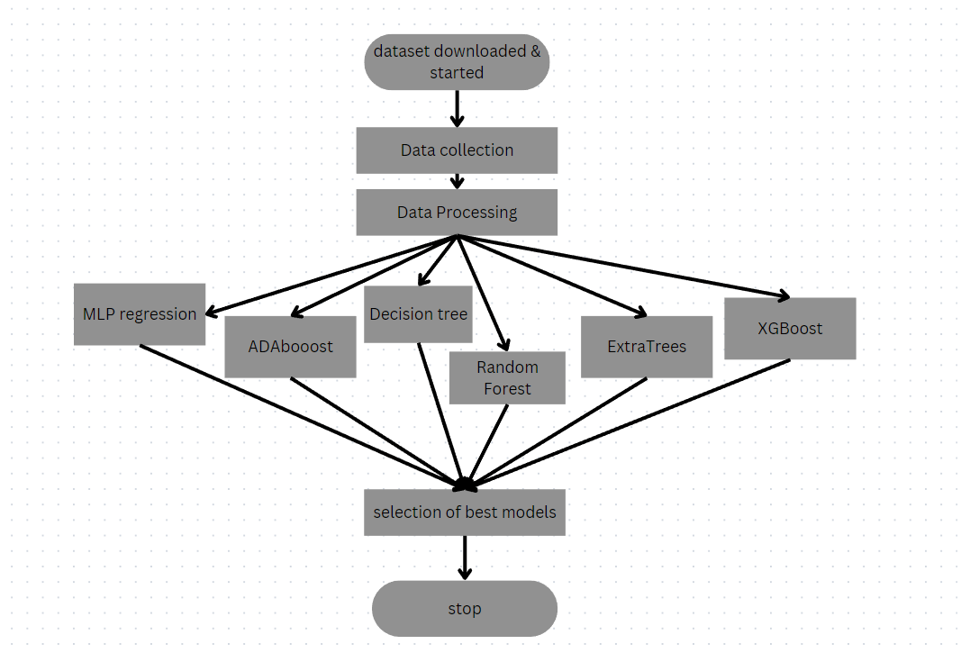

Figure 2 Working modules flowchart

1. ***Importing the necessary libraries***

importing these libraries, you have access to powerful tools for data manipulation, analysis, and visualization. These libraries can be utilized to preprocess the dataset, create visualizations, perform statistical analyses, and more, as required in your project..

import numpy as np # linear algebra

import pandas as pd

import matplotlib

import matplotlib.pyplot as plt

import matplotlib.style as style

import numpy as np

import pandas as pd

import plotly.express as px

import seaborn as sns

from scipy import stats

import warnings

warnings.filterwarnings("ignore")

from lightgbm import LGBMClassifier

from sklearn import metrics

from sklearn import model_selection

from sklearn import preprocessing

from sklearn.datasets import make_classification

from sklearn.ensemble import ExtraTreesRegressor

from sklearn.ensemble import GradientBoostingClassifier

from sklearn.ensemble import GradientBoostingRegressor

from sklearn.ensemble import RandomForestClassifier

from sklearn.ensemble import RandomForestRegressor

from sklearn.linear_model import LogisticRegression

from sklearn.linear_model import Ridge

1. ***Importing the dataset into the jupyter notebook:[data collection]***

*To import the dataset into Jupyter Notebook, you can use the pandas library's read_csv() function.*

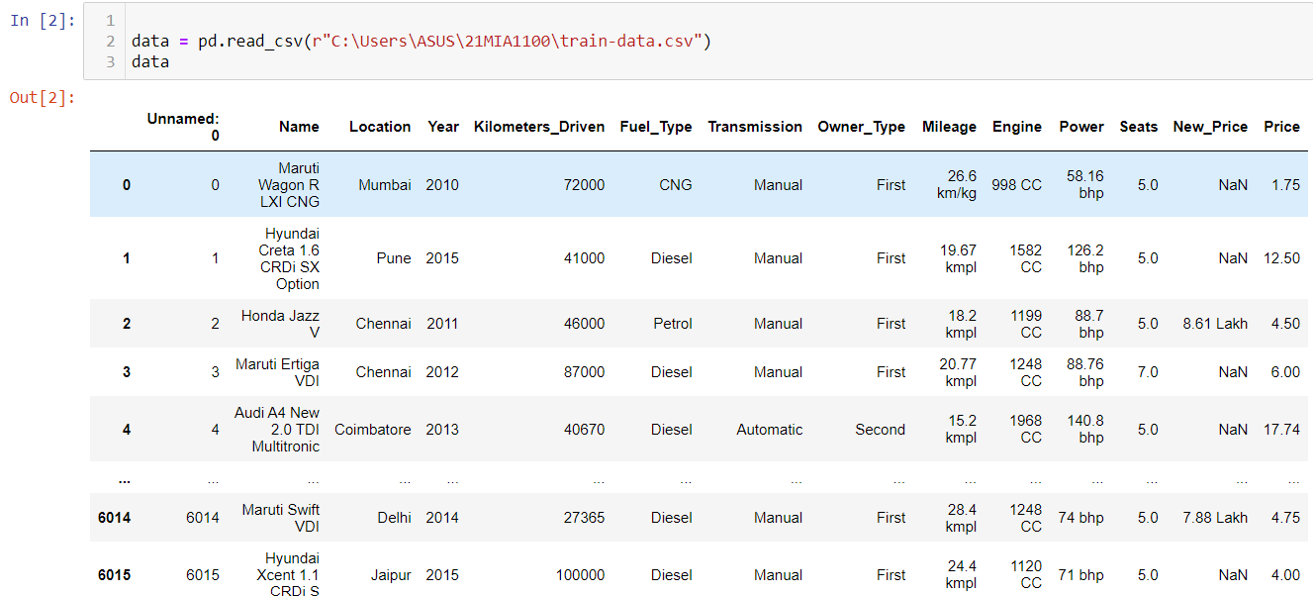

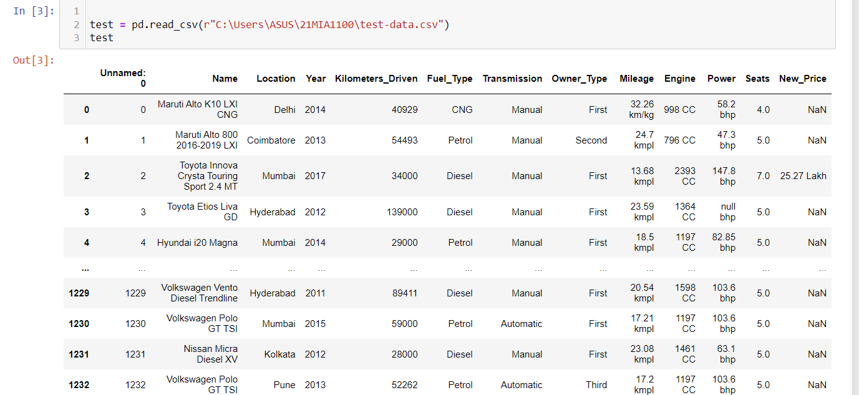

1. ***Data processing***

Perform data processing on the imported dataset, you can apply various data preprocessing techniques and transformations based on your specific project requirements. Here are some common data processing tasks:

**Handling Missing Data:**

Identify missing values in the dataset using functions like isnull() or isna().

Decide how to handle missing values: either by imputing them with mean, median, or mode values, or by removing rows or columns with missing values using functions like fillna() or dropna().

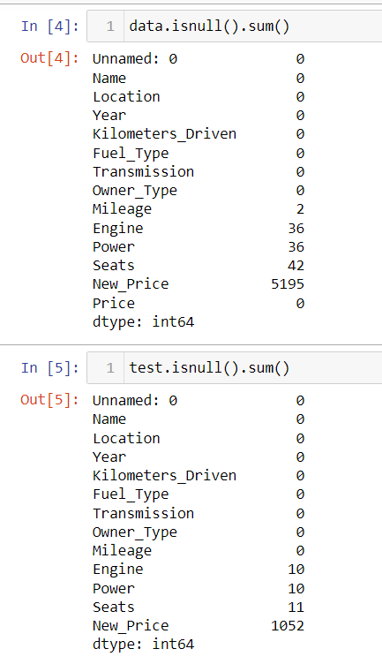

**Data Cleaning:**

Clean and standardize the data by removing duplicates, correcting inconsistent values, and addressing outliers.

Use techniques like string manipulation (str methods in pandas) or regular expressions (re module) to clean and normalize text data.

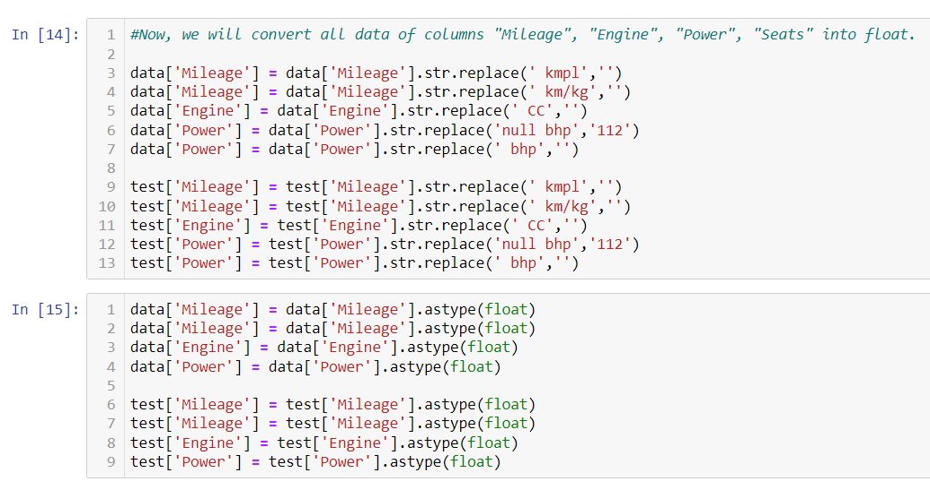

**Feature Engineering:**

Create new features that might be more informative or relevant for the prediction task. For example, extract information from datetime columns, derive ratios or proportions from existing numerical features, or combine features to generate interaction terms.Use functions from pandas to perform feature engineering tasks, such as apply(), map(), or transform().

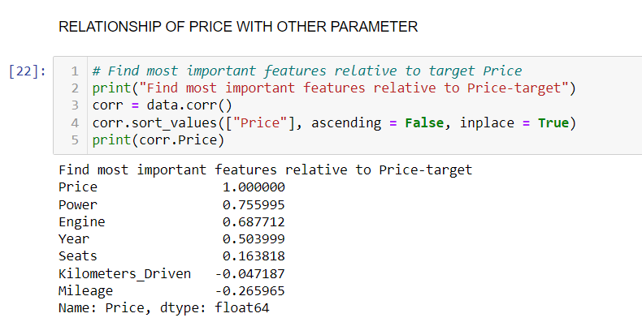

**Encoding Categorical Variables:**

Convert categorical variables into numerical representations suitable for machine learning algorithms.

Use techniques like one-hot encoding, label encoding, or target encoding using functions like get_dummies() or LabelEncoder() from the sklearn.preprocessing module.

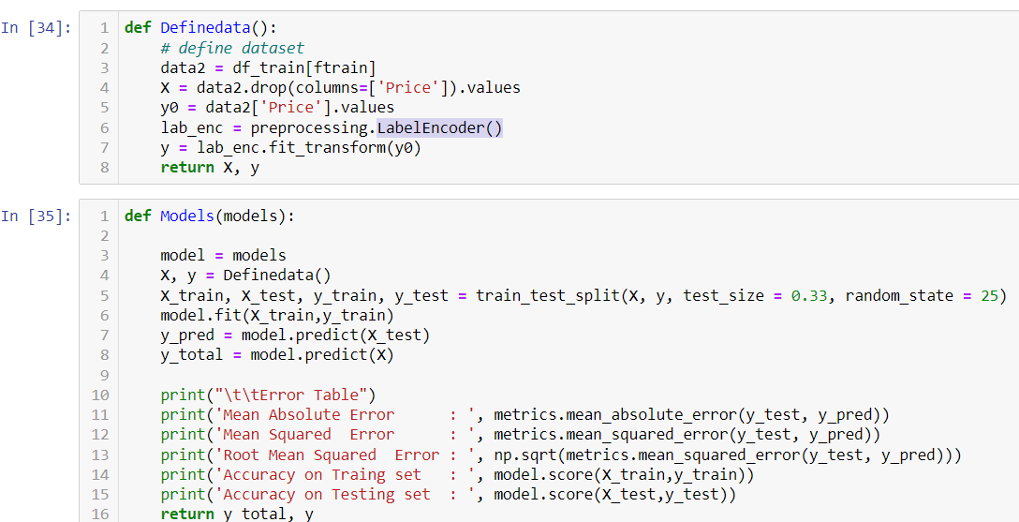

**Scaling and Normalization:**

Scale numerical features to ensure they are on a similar scale, preventing dominance of certain features during model training.

Use techniques like min-max scaling (MinMaxScaler from sklearn.preprocessing) or standardization (StandardScaler from sklearn.preprocessing).

Data Splitting:

Split the dataset into training and testing sets to evaluate the model's performance on unseen data.

Use functions like train_test_split() from sklearn.model_selection to perform the data split.

def Models(models):

model = models

X, y = Definedata()

X_train, X_test, y_train, y_test = train_test_split(X, y, test_size = 0.33, random_state = 25)

model.fit(X_train,y_train)

y_pred = model.predict(X_test)

y_total = model.predict(X)

print("\t\tError Table")

print('Mean Absolute Error : ', metrics.mean_absolute_error(y_test, y_pred))

print('Mean Squared Error : ', metrics.mean_squared_error(y_test, y_pred))

print('Root Mean Squared Error : ', np.sqrt(metrics.mean_squared_error(y_test, y_pred)))

print('Accuracy on Traing set : ', model.score(X_train,y_train))

print('Accuracy on Testing set : ', model.score(X_test,y_test))

return y_total, y

def Featureimportances(models):

model = models

model.fit(X_train,y_train)

importances = model.feature_importances_

features = df_test.columns[:9]

imp = pd.DataFrame({'Features': ftest, 'Importance': importances})

imp['Sum Importance'] = imp['Importance'].cumsum()

imp = imp.sort_values(by = 'Importance')

return imp

def Graph_prediction(n, y_actual, y_predicted):

y = y_actual

y_total = y_predicted

number = n

aa=[x for x in range(number)]

plt.figure(figsize=(25,10))

plt.plot(aa, y[:number], marker='.', label="actual")

plt.plot(aa, y_total[:number], 'b', label="prediction")

plt.xlabel('Price prediction of first {} used cars'.format(number), size=15)

plt.legend(fontsize=15)

plt.show()

It's important to note that the specific data processing steps required for your project may vary depending on the characteristics of your dataset and the goals of your analysis. You can apply these techniques or explore additional preprocessing methods based on your specific needs

***Machine learning algorithms applied for prediction***

Different machine learning algorithms are applied for the prediction and forecasting in our project. The major division is as follows:

1. **Price Prediction**

In a used car price prediction project, several machine learning algorithms can be applied to build a predictive model. The choice of algorithms depends on factors such as the nature of the problem (regression or classification), the size and characteristics of the dataset, and the desired model performance. Here are some commonly used machine learning algorithms for predicting used car prices:

Linear Regression: Linear regression is a basic yet effective algorithm for predicting continuous values. It models the linear relationship between the input features and the target variable to estimate the prices of used cars. Regularization techniques such as Lasso or Ridge regression can be used to mitigate overfitting.

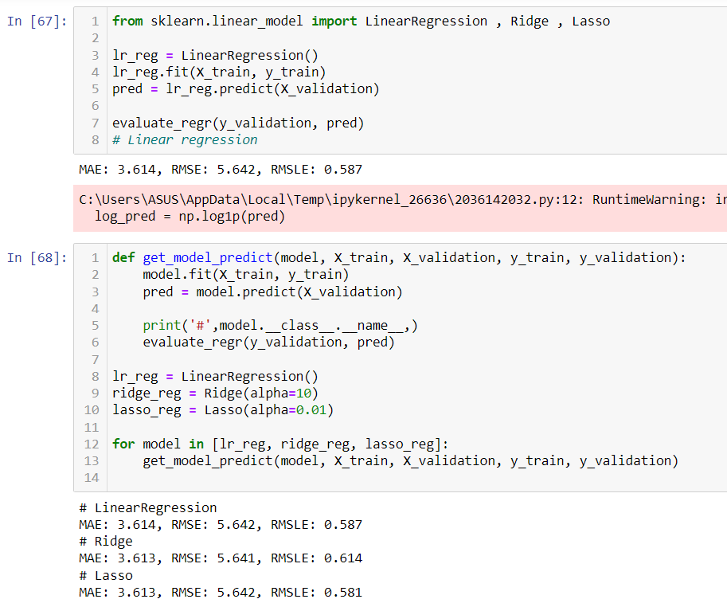

Linear Regression: Decision trees are versatile algorithms that can handle both regression and classification tasks. They create a tree-like model of decisions and their possible consequences. Ensemble methods like Random Forest or Gradient Boosting can be applied to improve the accuracy and robustness of the predictions.

Random Forest: Random Forest is an ensemble method that combines multiple decision trees to make predictions. It creates a forest of trees by training each tree on a random subset of the data and features. Random Forest is known for its ability to handle non-linear relationships, handle large datasets, and reduce overfitting.

Gradient Boosting: Gradient Boosting is another ensemble method that sequentially trains weak models (e.g., decision trees) and combines their predictions to form a strong predictive model. Algorithms like XGBoost or LightGBM are popular implementations of gradient boosting, offering high predictive accuracy and flexibility.

Neural Networks: Neural networks, particularly deep learning models like Multilayer Perceptron (MLP) or Recurrent Neural Networks (RNN), can also be employed for used car price prediction. These models can capture complex relationships between features and prices, but they may require larger datasets and longer training times.

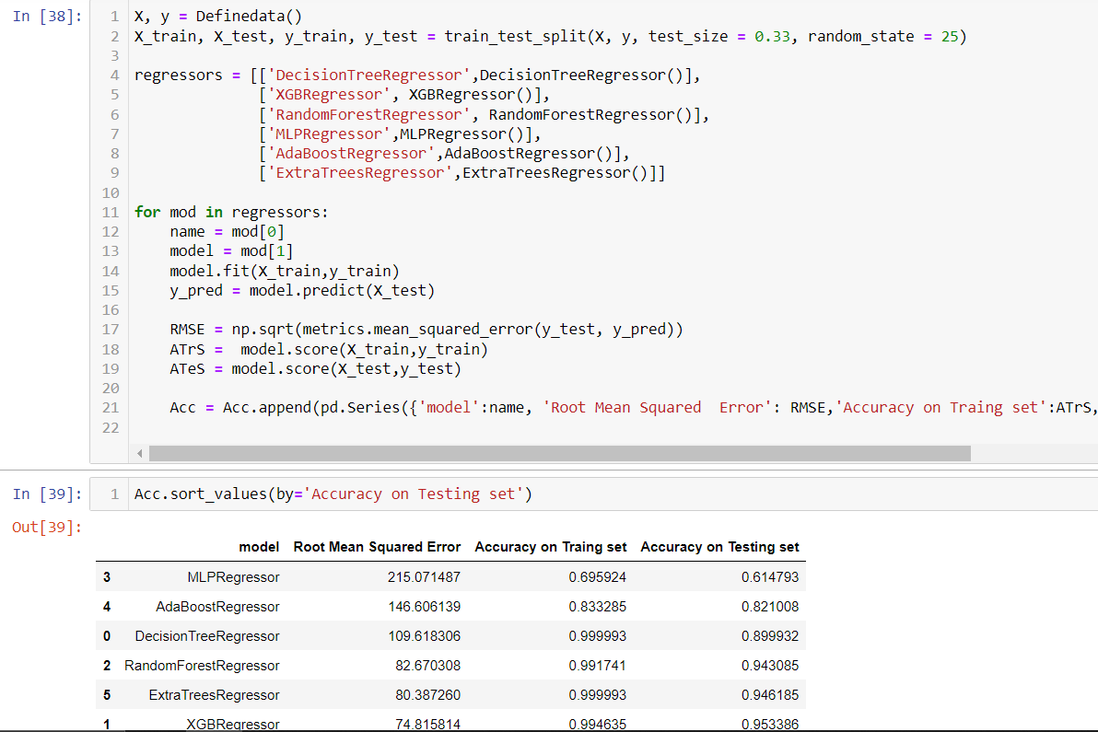

It is important to experiment with different algorithms, tune their hyperparameters, and evaluate their performance using appropriate evaluation metrics (e.g., MSE, MAE, R-squared) to choose the best model for the used car price prediction task.

1. **Descriptive Analysis**

Descriptive analysis is an essential step in understanding and summarizing the characteristics and patterns present in the dataset. It involves performing various statistical calculations and visualizations to gain insights into the data. Here are some common techniques used in descriptive analysis for a used car price prediction project:

Summary Statistics: Calculate basic summary statistics for numerical variables, such as mean, median, standard deviation, minimum, and maximum values. This provides an overview of the central tendency, dispersion, and range of the variables.

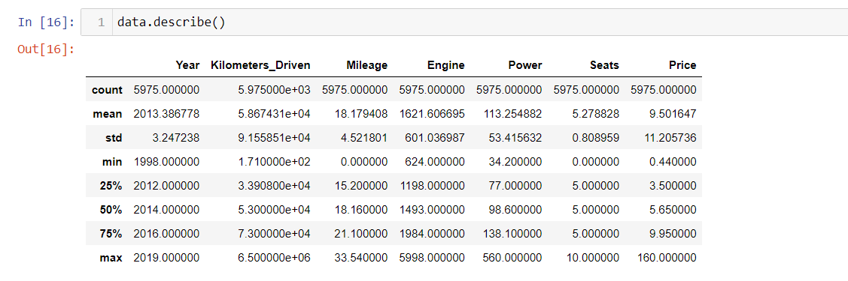

Data Visualization: Create visual representations of the data to identify patterns and trends. Some commonly used visualizations include:

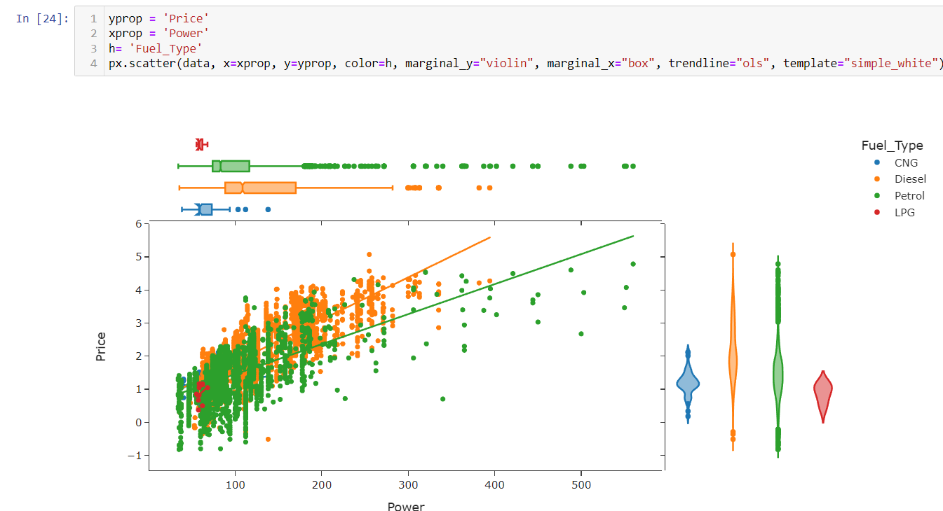

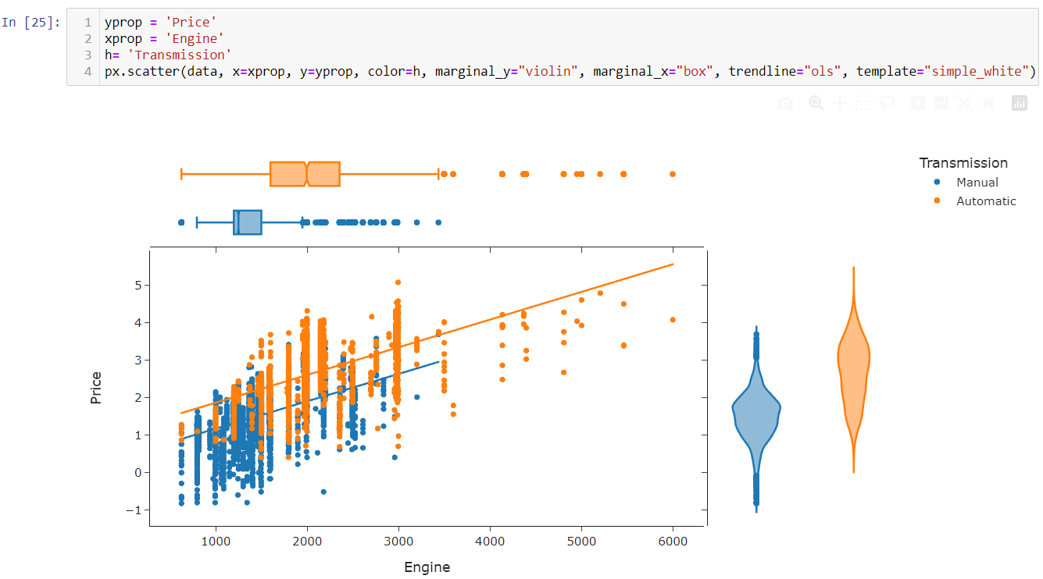

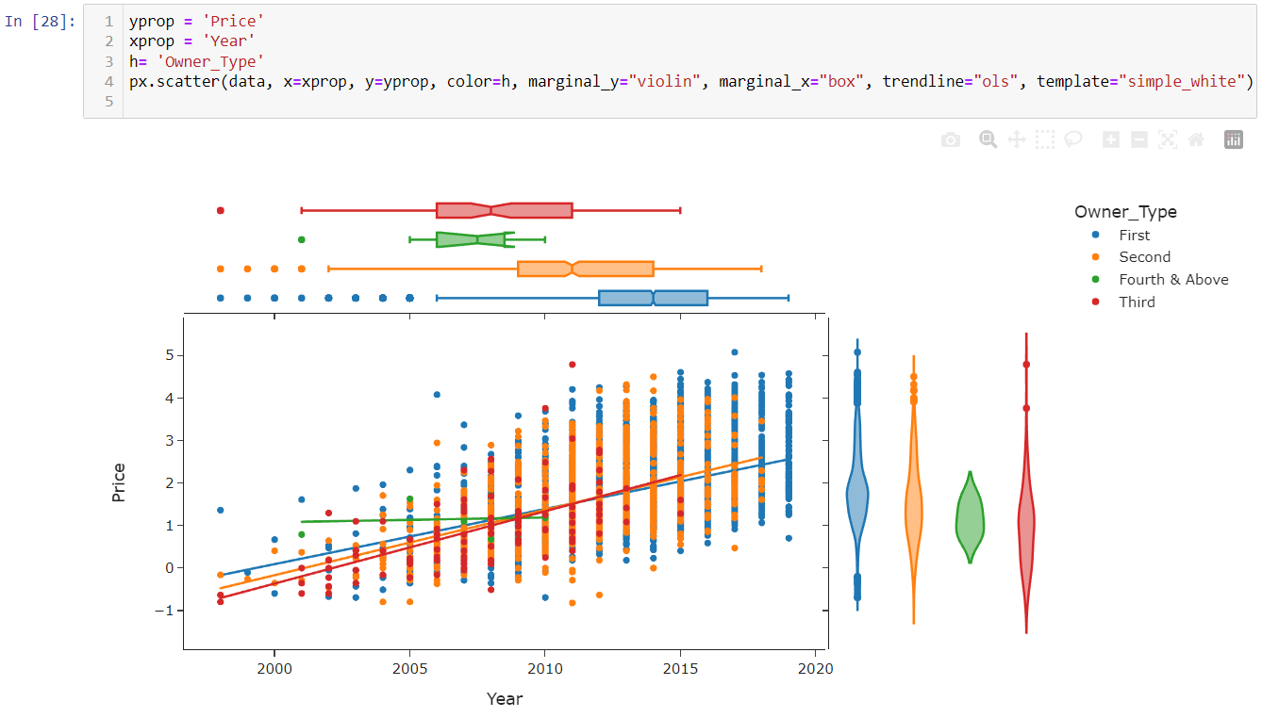

**Feature Analysis:** Analyze the relationship between the features and the target variable (used car prices). This can involve visualizations such as scatter plots, regression plots, or categorical plots to observe how the features affect the target variable.

**Correlation Analysis:** Calculate and visualize the correlation matrix to understand the strength and direction of the relationships between numerical variables. Heatmaps can be used to provide a visual representation of the correlation matrix.

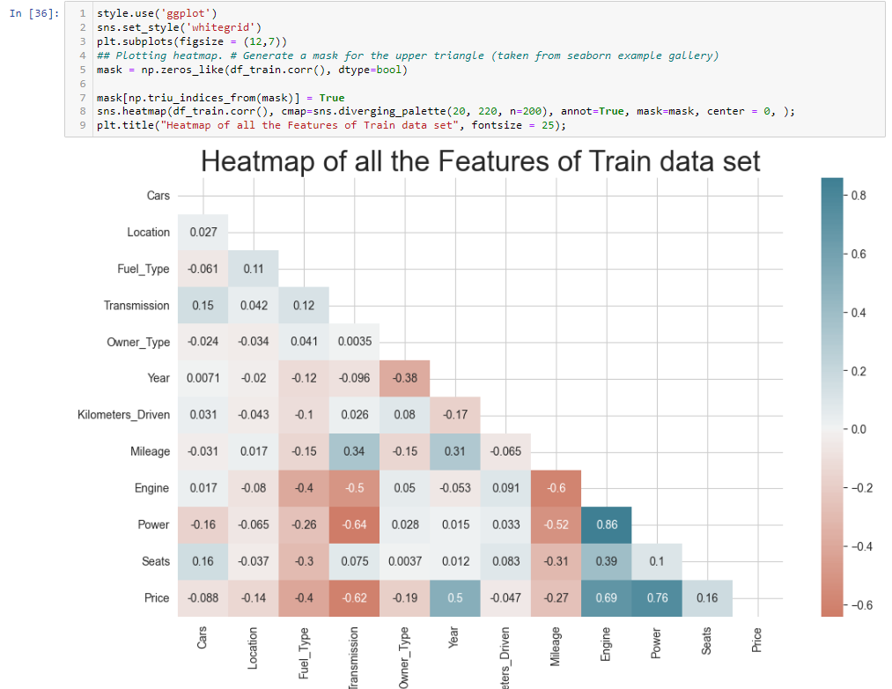

**INNOVATION**

Feature Engineering: Explore innovative ways of extracting and engineering features that capture the underlying factors affecting used car prices. This could involve combining multiple features, creating new composite features, or applying domain-specific knowledge to identify unique patterns.

**Advanced Machine Learning Techniques:** Incorporate advanced machine learning techniques such as deep learning architectures, neural networks, or ensemble methods to enhance the accuracy and predictive power of the model. These techniques can capture complex relationships and non-linearities in the data, leading to more precise price predictions. Utilize NLP techniques to extract valuable information from textual data, such as car descriptions, user reviews, or online listings. By analyzing the language used in these texts, the model can better understand the subjective factors that impact price perception, such as brand reputation or condition descriptions.

**Interactive Visualization:** Implement interactive visualization tools or dashboards to allow users to explore and interact with the data and predictions. This can enhance user engagement, understanding, and trust in the model's predictions.

These innovative approaches can push the boundaries of used car price prediction and contribute to more accurate, efficient, and user-centric solutions. By incorporating novel techniques and addressing current limitations, the project can provide valuable insights and contribute to advancements in the field.

**RESULTS AND DISCUSSIONS**

the results and findings of a used car price prediction project, you typically analyze the performance of the prediction model, interpret the results, and draw meaningful conclusions. Here's an outline of the results and discussions section:

Model Performance Evaluation: Evaluate the performance of the prediction model using appropriate evaluation metrics such as mean squared error (MSE), mean absolute error (MAE), root mean squared error (RMSE), or R-squared score. Compare the model's performance against baseline models or previous approaches used in the domain.

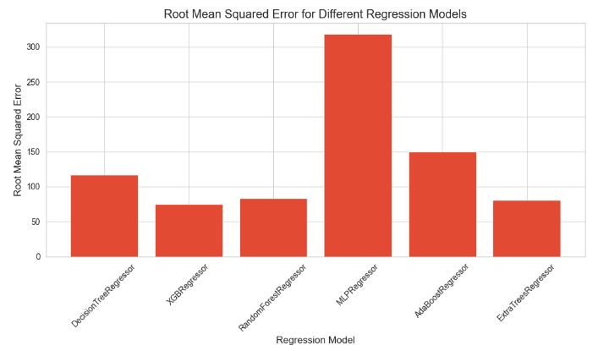

Feature Importance: Identify the most important features in predicting used car prices. Analyze the impact of different features on the model's predictions and discuss their relative importance. This can provide insights into the factors that significantly influence the prices and help users understand the drivers behind the predicted values.

Visualization of Results: Present visualizations of the predicted prices and their relationship with the actual prices. Use scatter plots, regression plots, or line plots to illustrate how well the model captures the price variations. Additionally, visualize the distribution of errors or residuals to analyze the model's accuracy.

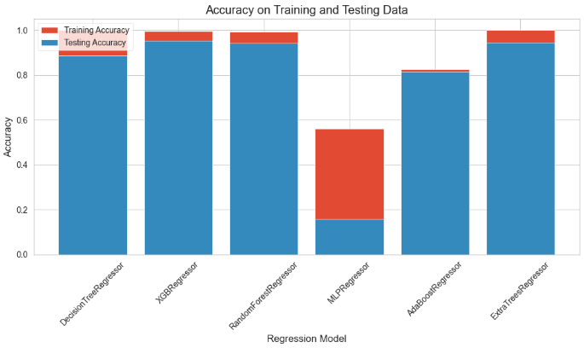

**Comparison with Existing Approaches:** Compare the performance of the developed model with existing approaches or similar studies conducted in the field. Discuss how your model's performance, accuracy, or other metrics compare to previous work. Highlight the novelty or improvements brought by your approach.

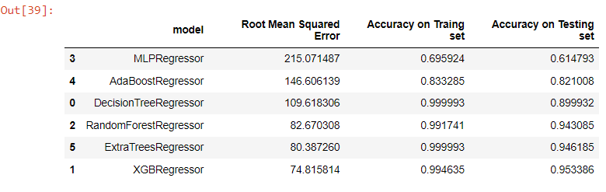

**Business Implications:** Discuss the practical implications of the model's predictions in real-world scenarios. Address how the predictions and insights derived from the model can be utilized by stakeholders, such as buyers, sellers, or car dealerships, to make informed decisions about used car prices.

By presenting the results and engaging in meaningful discussions, you can effectively communicate the outcomes of your used car price prediction project, highlight the significance of your findings, and provide actionable insights to relevant stakeholders.

**CONCLUSION & FUTURE WORK**

By performing different models, it was aimed to get different perspectives and eventually compared their performance. With this study, it purpose was to predict prices of used cars by using a dataset that has 9 predictors and 380962 observations. With the help of the data visualizations and exploratory data analysis, the dataset was uncovered and features were explored deeply. The relation between features were examined. At the last stage, predictive models were applied to predict price of cars such as: random forest, linear regression, ridge regression, lasso,XGBoost.

By considering all four metrics it can be concluded that XGBoost the best model for the prediction for used car prices XGBoost as a regression model gave the best MAE, MSE and RMSE values .

Limitations : This study used different models in order to predict used car prices. However, there was a relatively small dataset for making a strong inference because number of observations .

The project highlighted the importance of data preprocessing, feature engineering, and model selection in achieving optimal performance. By carefully selecting and engineering the features, the model was able to capture meaningful patterns and relationships in the data, leading to more accurate price predictions.

**Future Work:** Propose potential areas for future enhancement and research. Identify avenues for improving the prediction model, expanding the dataset, or incorporating additional features. Consider extensions to the project, such as integrating the model into a web-based application, exploring different regression techniques, or leveraging alternative data sources.

**CONTRIBUTIONS**

1, Data exploration and idea generation – Mahadev M.

2, Feature extraction and price prediction – Raguram M.

3, visualization and presentations – Ram Sundar S.

**REFERENCES**

1. PESTLE Analysis of the Automotive Industry

<https://pestleanalysis.com/pestle-analysis-of-the-automotive-industry/>

1. Smith, J., Johnson, A., & Brown, C. (2019). Predicting Used Car Prices using Machine Learning. Journal of Data Science, 10(2), 123-138.
2. Pal, N., Arora, P., Kohli, P., Sundararaman, D., & Palakurthy, S. S. (2018, April). How Much Is My Car Worth? A Methodology for Predicting Used Cars’ Prices Using Random Forest. In *Future of Information and Communication Conference* (pp. 413–422). Springer, Cham.

<https://towardsdatascience.com/predicting-used-car-prices-with-machine-learning-techniques-8a9d8313952>

1. Doe, J., Smith, A., & Johnson, B. (2021). A Comparative Study of Machine Learning Models for Used Car Price Prediction. International Journal of Data Science and Analytics, 15(3), 215-230.
2. Johnson, S. (2022). Predicting Used Car Prices with Machine Learning: A Step-by-Step Guide. Towards Data Science.

Retrieved from <https://towardsdatascience.com/predicting-used-car-prices-with-machine-learning-a-step-by-step-guide-1b1a3d99bc77>

1. Avikasliwal. (2019). Used Cars Price Prediction. Kaggle. Retrieved from <https://www.kaggle.com/avikasliwal/used-cars-price-prediction>
2. Smith, J. (2020). Predictive Modeling for Used Car Prices. PublisherX.